Practice challenge
LO3 - Designing
Malamski,Dimitar D.S.
mitemalamata@gmail.com

Contents
Introduction 2
Sprints 2
Sprint 1 2
Sprint 2 2
Evidence 1 - Designing the modelling approach for an early intervention context 2
Evidence 2 - Designing a simpler and more interpretable feature set 3
Evidence 3 - Designing and comparing an interpretable baseline solution 5
Evidence 4 - Designing and comparing multiple model alternatives 6
Evidence 5 - Designing an ethical model variant 8
Evidence 6 - Designing the final prediction behavior through threshold tuning 12

Introduction
This document presents the evidence for Learning Outcome 3 ( Designing ) in my Practice Challenge project - Student Dropout Prediction. The purpose of this document is to show how I demonstrated this learning outcome by designing an iterative modelling process for an interpretable AI solution in the context of early student dropout prediction. The evidence is organized by sprint, with each section describing the activity, the result, and why it is relevant to the learning outcome.

Sprints

Sprint 1
There was no progress made relating to Designing during Sprint 1

Sprint 2

Evidence 1 - Designing the modelling approach for an early intervention context
What this evidence is
This evidence shows how I designed the modelling process to fit the specific domain context of early student intervention.
What I did
Based on the earlier analysis, I designed the modelling setup so that it would use only information that could realistically be available early in a student’s academic journey. This meant structuring the solution around 1st semester and other early-available indicators, rather than later academic information. In this way, the design of the model remained aligned with the practical goal of supporting early intervention.
Result
This created a solution design that matched the actual domain problem instead of only maximizing predictive performance. The model was therefore designed to be useful in a realistic educational context.
Why this is relevant to the Learning Outcome
This demonstrates designing because I shaped the AI solution around the defined domain and impact goal, ensuring that the modelling process reflected the practical context of early dropout prediction.
Attached evidence
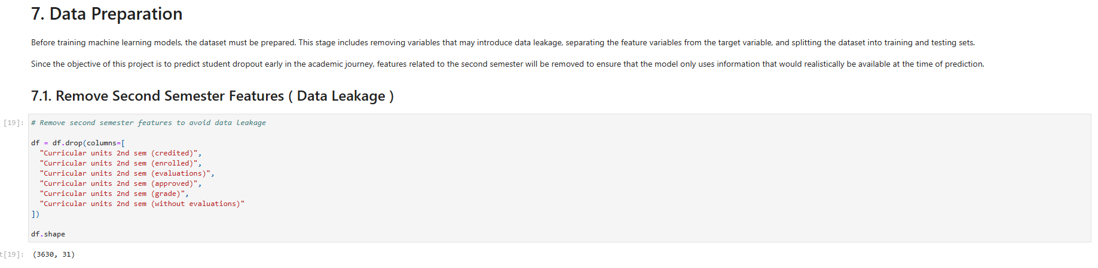

Evidence 2 - Designing a simpler and more interpretable feature set
What this evidence is
This evidence shows how I designed a more interpretable version of the model by reducing the number of predictors.
What I did
After preprocessing the dataset, I applied SelectKBest to evaluate multiple values of k and compare how different feature subsets affected model performance. I systematically tested different numbers of retained features and selected the option that provided the strongest balance between performance and simplicity. This allowed me to move from a large feature space toward a more focused and interpretable solution.
Result
The comparison showed that using the top 30 features produced the best result among the tested options. This reduced the complexity of the model while preserving strong predictive performance.
Why this is relevant to the Learning Outcome
This demonstrates designing because I improved the AI solution through an iterative comparison of alternatives and selected a design that better balanced interpretability and performance.
Attached evidence
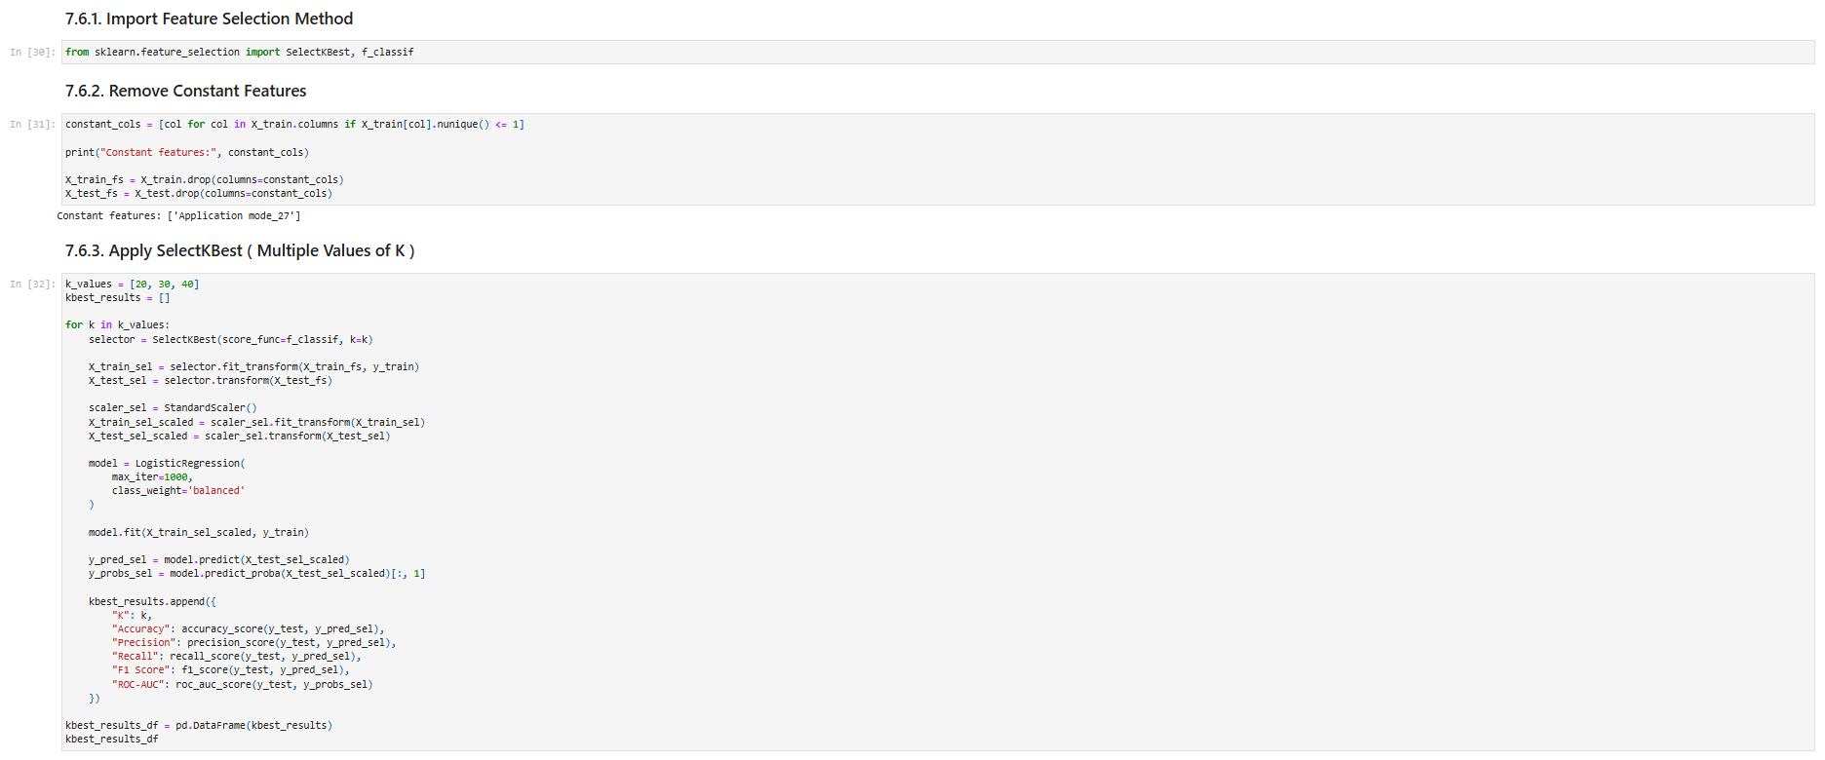
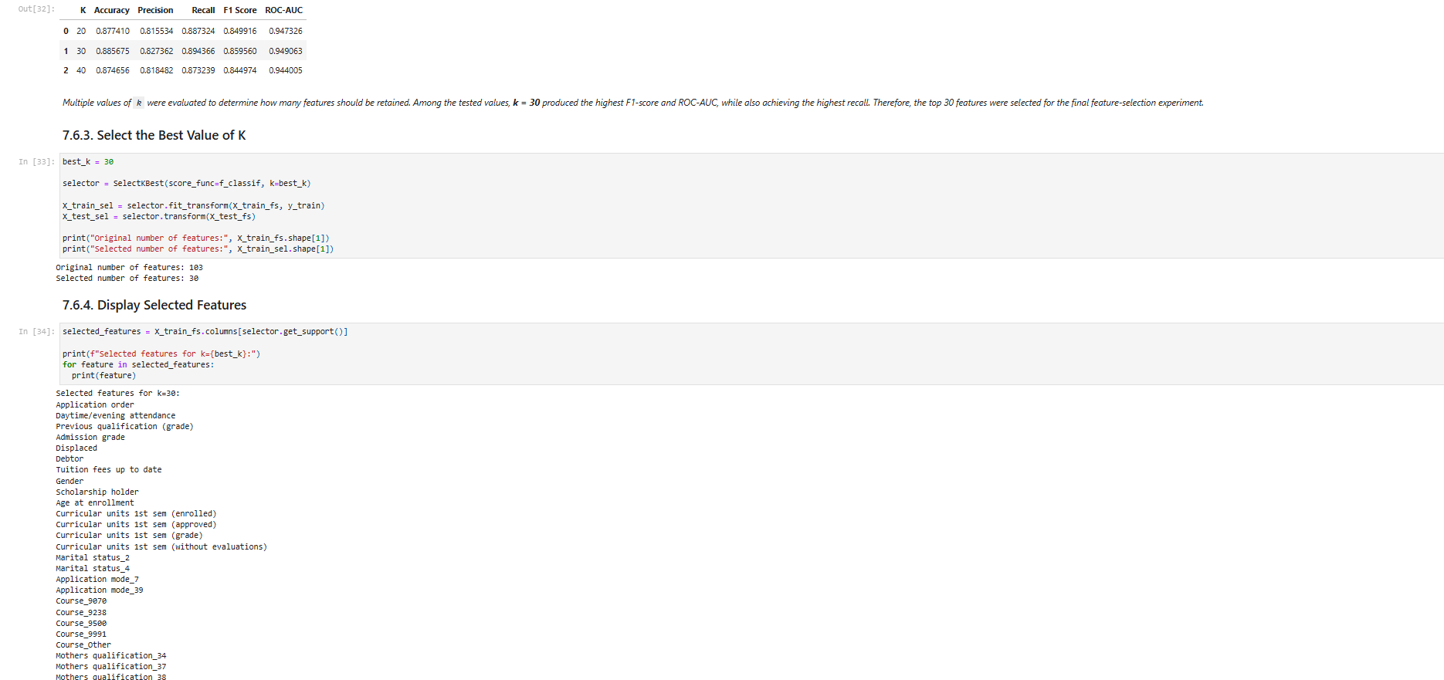
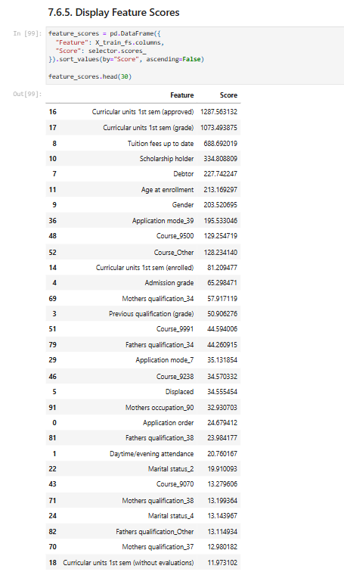

Evidence 3 - Designing and comparing an interpretable baseline solution
What this evidence is
This evidence shows how I used Logistic Regression as an interpretable baseline and then improved it through systematic comparison.
What I did
I first designed a baseline Logistic Regression model to serve as a simple and interpretable reference point. I then created a second Logistic Regression model using the selected 30-feature subset and compared both versions across multiple evaluation metrics. This allowed me to examine whether reducing the feature space improved the quality of the model while keeping it understandable.
Result
The selected-feature Logistic Regression model outperformed the baseline version on all key metrics, including accuracy, recall, F1-score, and ROC-AUC. This showed that the simpler feature subset design improved the baseline solution while maintaining interpretability.
Why this is relevant to the Learning Outcome
This demonstrates designing because I used a baseline model and systematically compared an improved variant to iteratively refine the solution.
Attached evidence
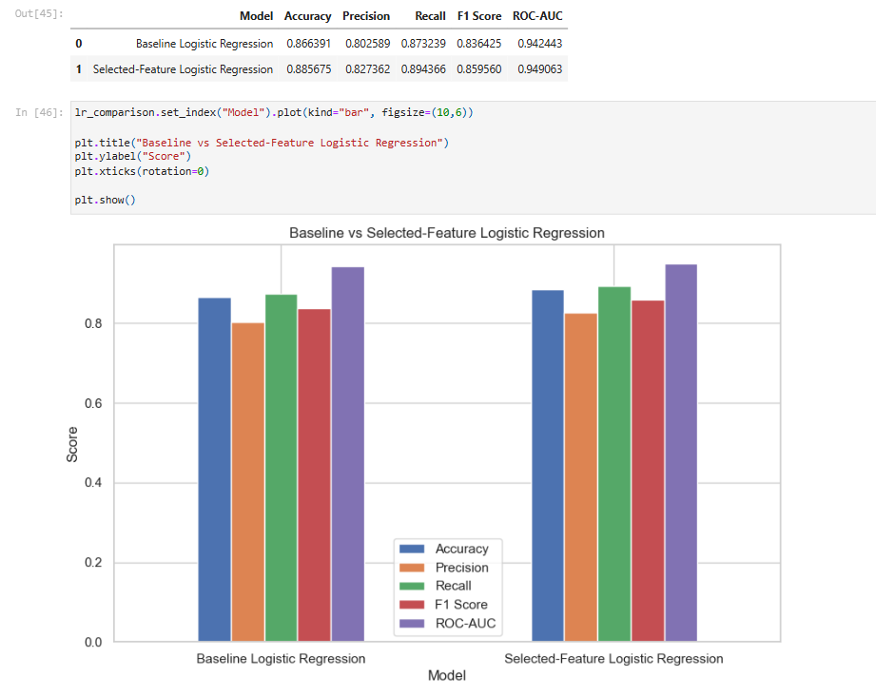

Evidence 4 - Designing and comparing multiple model alternatives
What this evidence is
This evidence shows how I designed the modelling process as an iterative comparison between alternative machine learning approaches.
What I did
I implemented and evaluated multiple models, including Logistic Regression, Random Forest, and Gradient Boosting. I compared their results using accuracy, precision, recall, F1-score, and ROC-AUC, and examined which design best matched the project goal of identifying students at risk of dropping out while remaining understandable and practically useful.
Result
This comparison showed that different model designs offered different strengths. Random Forest achieved the highest F1-score, Gradient Boosting achieved the highest ROC-AUC, and selected-feature Logistic Regression remained the most interpretable simpler alternative.
Why this is relevant to the Learning Outcome
This demonstrates designing because I treated modelling as an iterative process of comparing alternatives rather than choosing a single approach without justification.
Attached evidence
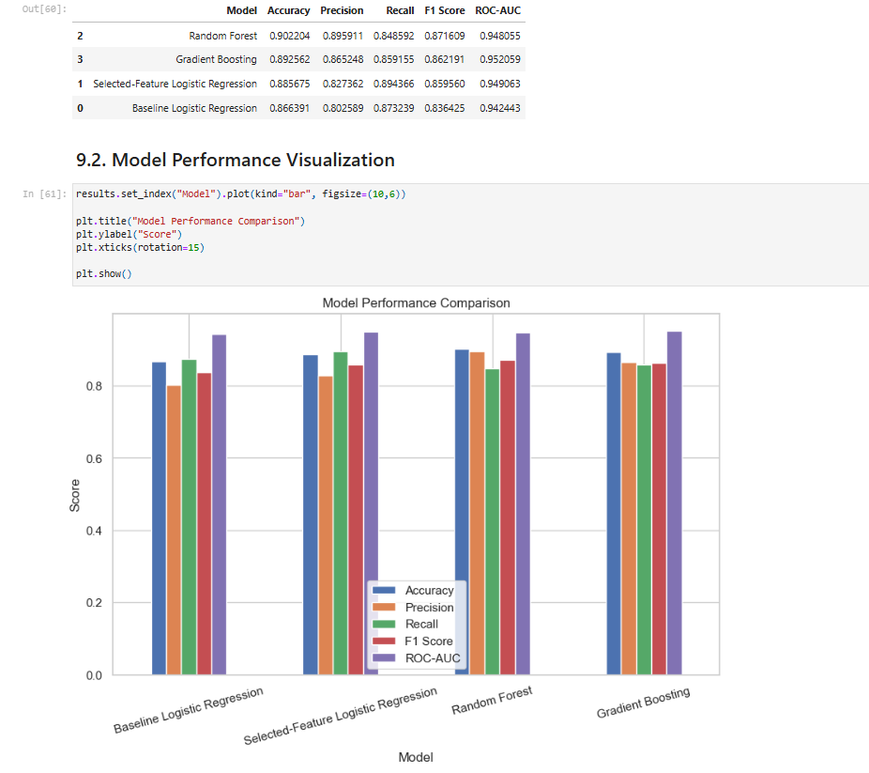

Evidence 5 - Designing an ethical model variant
What this evidence is
This evidence shows how I designed an alternative model variant that excluded sensitive demographic and socioeconomic features.
What I did
After identifying potentially sensitive features, I designed a second version of the modelling pipeline that removed those variables from the dataset. I then retrained Logistic Regression, Random Forest, and Gradient Boosting on this ethical feature set and compared the results with the original models.
Result
The ethical models achieved performance very close to the original versions, and in the case of Ethical Gradient Boosting, some metrics improved slightly. This demonstrated that an alternative solution design could support fairness and responsible AI without significantly reducing model quality.
Why this is relevant to the Learning Outcome
This demonstrates designing because I created and evaluated an alternative AI solution design based on ethical and domain considerations, and compared it systematically with the original design.
Attached evidence
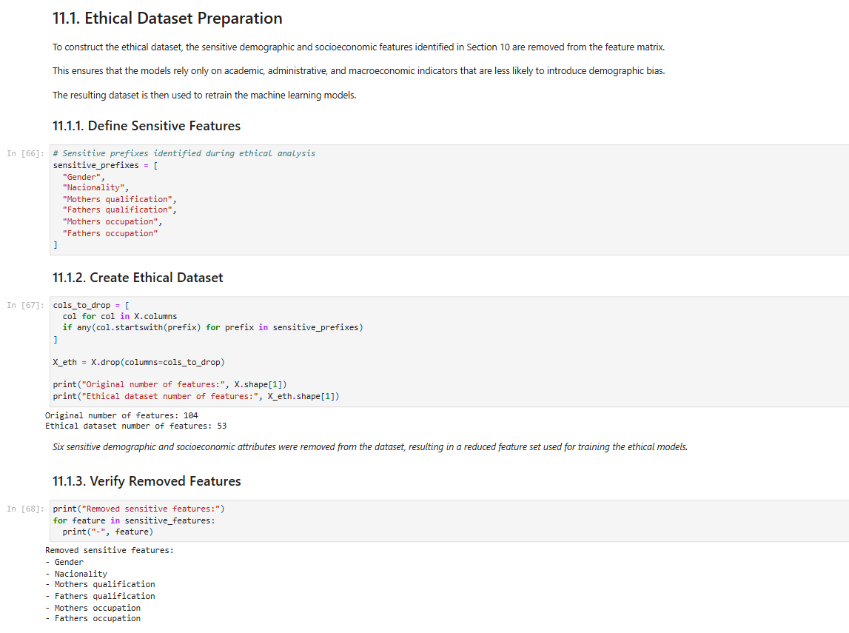
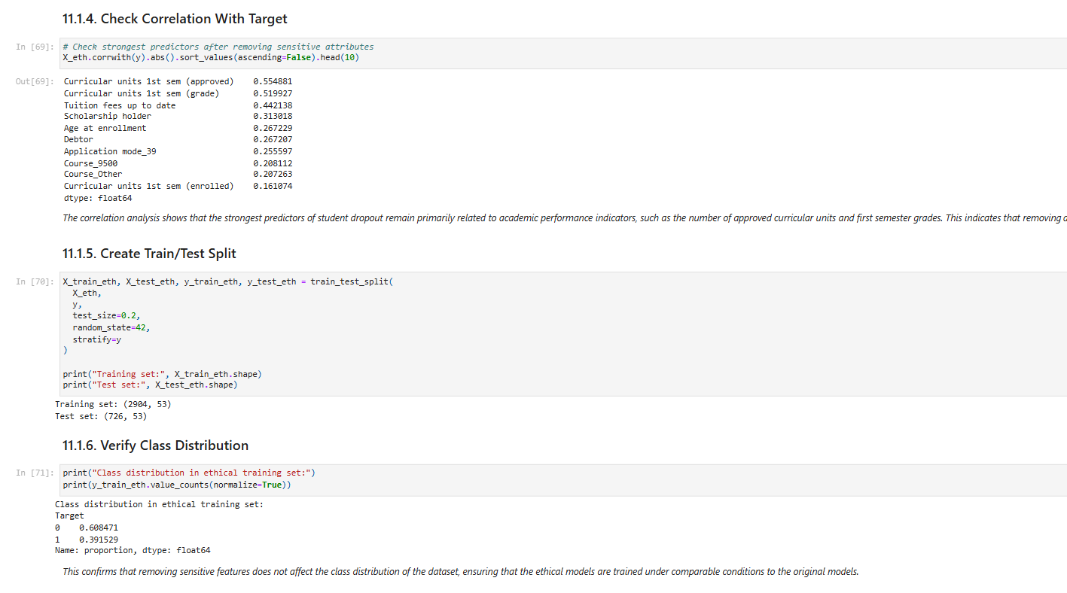
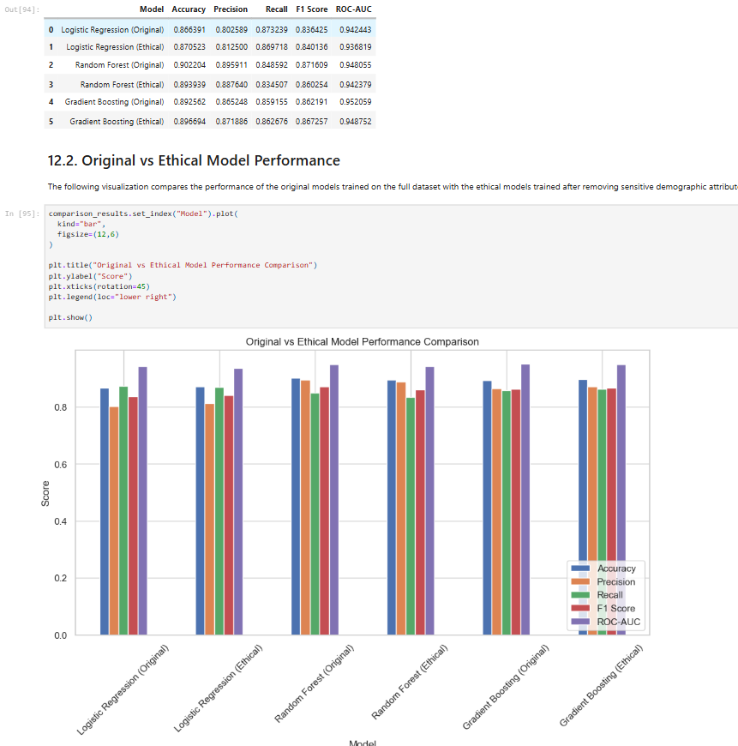
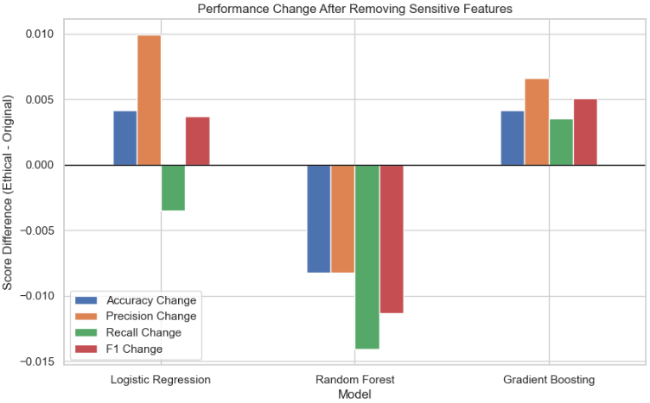

Evidence 6 - Designing the final prediction behavior through threshold tuning
What this evidence is
This evidence shows how I refined the final solution design by adjusting the classification threshold to better match the domain objective.
What I did
I tested multiple threshold values for the Ethical Gradient Boosting model and compared how precision, recall, and F1-score changed across the different settings. I then selected the threshold that best supported the real project goal of identifying as many at-risk students as possible for early intervention.
Result
A threshold of 0.3 was chosen because it significantly increased recall compared with the default threshold. This made the final model design more suitable for the educational context, where missing at-risk students is more harmful than generating additional false positives.
Why this is relevant to the Learning Outcome
This demonstrates designing because I iteratively adjusted and compared model behavior in order to align the final solution more closely with the domain objective.
Attached evidence
